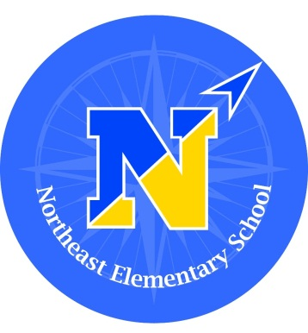
Northeast Elementary School

Dr. Shawn Marinello, Principal
Mrs. Kathy Lane, Assistant Principal

82 Scofieldtown Road , Stamford CT 06903 -- Phone: (203) 977-4469 Fax: (203) 977-4312

"Northeast Elementary School empowers every student by providing an exemplary educational foundation that includes: critical and creative thinking, social-emotional learning, physical education, music, and the arts in a collaborative and inclusive learning environment."

March 30, 2023

Dear Grade 5 Northeast Families,

In the upcoming weeks, your child will be participating in state mandated testing for the SBAC in both ELA and Math.

We have been preparing students all year through our everyday core instruction. We are also beginning to review and provide practice opportunities for students to reacquaint with the format and types of questions that they will experience during the testing.

Our communication to the students has been: to come prepared for testing, having had a good breakfast, a good night’s sleep and a “do your best” attitude. We look to you, as our partners in your child’s success, to share similar messages.

We are providing the schedules below to help you in planning, and to encourage school attendance on these dates. Please be advised that we have provided more time than expected for most students to complete each specific test to allow for optimal testing conditions for each of our students. These times will be in the afternoons of the testing date and on make-up days, as needed.

SBAC

Monday, May 1 ELA Part 1 --- Computer Adaptive Test 8:30 – 11:00
Tuesday, May 2 ELA Part 2-- Computer Adaptive Test 8:30 – 11:00
Thursday, May 4 Math -- Computer Adaptive Test 8:30 – 11:00
Friday, May 5 Math -- Performance Task 8:30 – 11:00

Thank you in advance for respecting the dates and times in getting students to school on time, and avoiding interruptions in their school day. We wish each student success in their efforts.

Dr. Shawn Marinello Mrs. Kathy Lane Mrs. Patricia Mould
Principal Assistant Principal Teacher Leader for Student Support

